**University of Electronic **

**Sciences and Technology**

**of China**

**Topic**:

**DSP APPLICATION IN RADAR:**

**“Moving target indicator MTI”**

**ID Number**: **201224040107**

**Student Name**: **DEMBELE Salif Nabouna**

**School**: **Physical Electronic**

**Professor**: **Jing-Ran Lin**

Contents

1. Intoduction
2. Moving target indicator MTI
3. Two pulse canceller
4. Three pulse canceller
5. Conclusion

**1. Introduction**

RADAR transmits radio signals at distant objects and analyses the reflections. The data gathered can include the position and movement of the object, also radar can identify the object through its "signature" - the distinct reflection it generates. There are many forms of RADAR - such as continuous, CW, Doppler, synthetic aperture; and they're used in many applications, from air traffic control to weather prediction. In the modern Radar systems digital signal processing (DSP) is used extensively. At the transmitter end, it generates and shapes the transmitted pulses, controls the antenna beam pattern while at the receiver, DSP performs many complex tasks, including STAP (space time adaptive processing) - the removal of clutter, and beam-forming (electronic guidance of direction).

**2. Moving target indicator MTI:**

The clutter is a term used to describe any object that may generate unwanted radar returns that may interfere with normal radar operations.

In CW radars, clutter is avoided or suppressed by ignoring the receiver output around DC, since most of the clutter power is concentrated about the zero frequency bands. Pulsed radar systems may utilize special filters that can distinguish between slow moving or stationary targets and fast moving ones. This class of filters is known as the Moving Target Indicator (MTI). In simple words, the purpose of an MTI filter is to suppress target-like returns produced by clutter, and allow returns from moving targets to pass through with little or no degradation. In order to effectively suppress clutter returns, an MTI filter needs to have a deep stop-band in DC and at integer multiples of the pulse repetition frequency PRF. MTI filters can be implemented using delay line cancels the frequency response of this class of MTI filters is periodic, with nulls at integer multiples of the PRF.figure (1) show that coherent MTI radar.

I will implement and show two types of MTI two-pulse canceller and three pulse canceller.

1. **Two pulse canceller:**

A two-pulse canceller is used if the clutter component [assuming DC only] remains constant in a given range and can be eliminated by subtracting the output from two successive pulses.

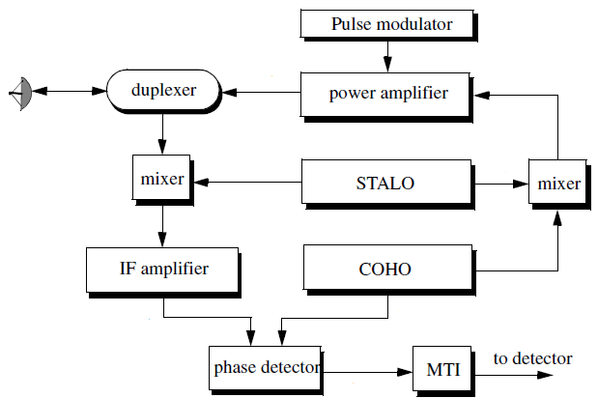

Figure (1) Coherent MTI radar



Figure (2) block diagram of two pulse canceller

In practice, the clutter has a power spectrum that covers frequencies above DC. The two pulse canceller will attenuate low frequency components but may not totally reject clutter. Other Optimum Design Methods are based on the assumption of the clutter and the desired signal.

From the figure (2) the canceler’s impulse response is denoted as h(t) . The output y(t) is equal to the convolution between the impulse response h(t) and the input x(t). The single delay canceler is often called a “two-pulse canceler”.

The delay T is equal to the pulse repetition interval (PRI) of the radar (1/fr ). The output signal is

y (t)=x(t)-x(t-T)

The impulse response of the canceler is given by

*h**t* = δ*t* – δ*t* – *T*

Where δ (*t*) is the delta function. It follows that the Fourier transform (FT) of h (t) is:

$$H(ω){=1-e}^{-iωT}$$

Where ω =2πf

In the Z-domain, the single delay line canceler response is

H (z) =1 - z-1

The power gain for the single delay line canceler is given by

|H (ω) |2 = H (ω) H∗ (ω) = (1- e –jωT) (1 - ejωT)

=1+1-(e –jωT+ ejωT) = 2-2cos (ωT)

And using the trigonometric identity 2-2cos (2θ) =4sin(θ)yields

|H (ω) |2=4(sin (ωT/2))2

Figure (3) show the amplitude response for two pulse canceller

1. **Three pulse canceller:**

Also called double canceller since it requires three distinct input pulses before an output can be read. In practice, the clutter has a power spectrum that covers frequencies above DC. The two pulses canceller will attenuate low frequency components but may not totally reject clutter. Three-pulse canceller with its transform function equivalent to FIR filter is 0.5  *z*1  0.5*z*2 .This attenuates further the components near DC. It has more efficiency than two pulse canceller; the double line canceler impulse response is given by

*h**t* = δ*t* – 2δ*t* – *T*+δ*t* – 2*T*

The power gain for the double delay line canceler can be expressed by

|H (ω) |2=|H1 (ω) |2|H1 (ω) |2

Where |H1 (ω) |2 is the single line canceler power gain then

|H(ω) |2=16sin ((ωT/2)) 2

Figure (4) shows two configurations of three pulse canceller, in the z-domain, we have

H (z) =1 -2 z-1+z-2



Figure (4) two configuration of three pulse canceller

we can also design MTI system by FIR filters . The transfer function of two-pulse canceller is equal to 1 *z*1 that means a first order FIR filter in cascade form and employs only one two-input adders and 2 multipliers, also the summation of weight factors equal zero because causal FIR of order N characterized by the transfer function $H\left(z\right)=\sum_{k=0}^{N}{h(k)z^{-1}}$ Which is polynomial in z-1 of degree N. And three-pulse canceller with its transform function equivalent to FIR filter is 0.5  *z*1  0.5*z*2 from three pulse canceller we require 3 multipliers and two two-input adders .figure (5) show FIR filters of both MTI types and figure (6) show the amplitude response of both types .

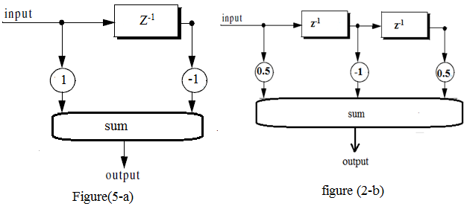

Figure (5) block diagram of two and three pulses canceller

Figure (6-a)



Figure (6-b)

Figure (6): Amplitude response of two pulses and three pulses canceller

In general we can design N pulse canceller characterized by N+1 coefficient require N+1 multipliers and N two-input adder . also MTI can designed by N-stage tapped delay line implementation, when the weights are chosen such that they are the binomial coefficients (coefficients of the expansion (1-x)N ) with alternating signs, then the resultant MTI is equivalent to N-stage cascaded single line cancelers.

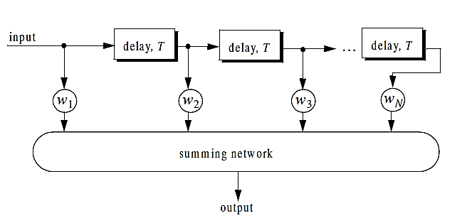

Figure (7): N pulses canceller implemented by N-stage cascaded signal line canceller.

**3.Conclusion:**

In this report I’ve presented a brief overview of digital signal processing applications in MTI. Many applications in radar can be implemented in Digital Signal Processor like Matched filtering, Constant False alarm ratio CFAR , Beam-forming and other application because of their flexibility, programmability and the ability to attain high precisions .